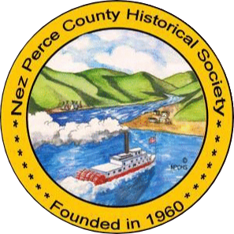

**Lewiston Chinese Legacy Project Donation Form**

Donation Amount: ________________ Date: ___________________

Check#: ____________

Name: ____________________________________________________

Address: ___________________________________________________

Email: ____________________________________________________

Phone: ___________________________________________________

In Honor of: _______________________________________________

(OPTIONAL)

In Memory of: ______________________________________________

(OPTIONAL)

**45 3rd St. Lewiston, ID 83501**

**Tues. – Sat. 10:00 a.m. – 4 p.m.**

**(208) 743-2535**

**[npcmuseum@gmail.com](mailto:npcmuseum@gmail.com)**

**Nez Perce County Historical Society is 501 C (3) corporation. Your gift may be tax deductible on your federal tax returns. In addition, if you pay Idaho income taxes, contributions to the Nez Perce County Historical Society may be eligible for additional tax credits for educational institutions. Please consult your tax advisor for more information.**