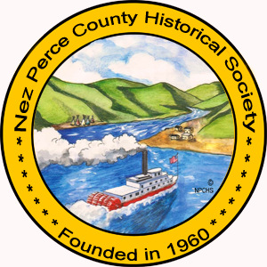

Nez Perce County Historical Society & Museum
Inventory of Event Tables & Chairs

There should be 1 handcart, 14 tables and 288 chairs available for your event. Please inventory after every use. All items must be returned in the same condition in which they were received. They should be cleaned if needed before storing in the utility trailer. Just a reminder we charge for all missing and damaged chairs and tables. Inventory with NPCHS staff will be completed with renter the day of returning trailer. We appreciate your help in the continuation of this fundraiser for the NPCHS.

__________ Tables

__________ Chairs

__________ Broken Tables ($150.00 each)

__________ Broken Chairs ($20.00 each)

__________ Hand Cart

